🎵 CNN-Based Musical Instrument Recognition

1. Introduction
The objective of Week 7–8 is to deploy the trained CNN-based musical instrument classification model as a fully functional end-to-end system. This phase focuses on transforming the trained model into a user-accessible application that can accept audio input, visualize results, and generate structured outputs such as JSON and PDF reports.

2. Objectives of Deployment Phase
The main objectives of this phase are:
- To build an output module for instrument detection visualization
- To optionally deploy the system using a Streamlit web application
- To export prediction results in JSON and PDF formats
- To achieve an end-to-end pipeline from audio input to report generation

3. End-to-End System Pipeline
The deployed system follows the pipeline shown below:
Audio Input (WAV)
↓
Audio Preprocessing
↓
Mel Spectrogram Generation
↓
CNN Model (ONNX) Inference
↓
Instrument Prediction
↓
Visualization + JSON/PDF Report Generation
This pipeline ensures smooth processing from raw audio input to final outputs.

4. Audio Input Module

Description
The system accepts audio input in the form of WAV files uploaded by the user.

Functionality
- Users upload audio files through the web interface
- Audio is temporarily stored for processing
- Audio playback is provided for user verification

Purpose
This module enables real-world usage by allowing users to test the system with their own audio recordings.

5. Audio Preprocessing

Description
Before inference, the uploaded audio undergoes preprocessing to ensure compatibility with the trained model.

Preprocessing Steps
- Conversion of stereo audio to mono
- Resampling to a fixed sampling rate
- Generation of Mel Spectrogram
- Conversion to decibel (dB) scale
- Normalization of spectrogram values
- Padding or cropping to a fixed size

Purpose
Preprocessing ensures that all audio inputs follow a standardized format, improving prediction accuracy and consistency.

6. Instrument Detection Visualization Module

Description
To visually represent how the model analyzes audio, a Mel Spectrogram visualization is generated.

Visualization Details
- X-axis represents time
- Y-axis represents Mel frequency
- Color intensity represents signal energy

Features
- Spectrogram displayed directly in the application
- Option to download the spectrogram image

Importance
Visualization improves interpretability and helps users understand the audio features used for prediction.

7. Model Deployment Using ONNX

Description
The trained CNN model is exported to ONNX (Open Neural Network Exchange) format for deployment.

Advantages of ONNX
- Platform-independent
- Lightweight and efficient
- Faster inference
- Suitable for production environments

Inference Process
- ONNX Runtime loads the trained model
- Preprocessed spectrogram is provided as input
- Model outputs class probability scores

8. Instrument Prediction Output

Description
The model outputs probability scores for each instrument class.

Processing Steps
- Softmax is applied to model outputs
- Top-K instrument predictions are selected
- Class indices are mapped to instrument names

Output
The predicted instrument and confidence scores are prepared for further visualization and reporting.

9. JSON Output Generation

Description
Prediction results are exported in JSON format for structured, machine-readable output.

JSON Content
- Predicted instrument
- Class index
- Probability scores
- Top-K predictions

Use Cases
- Backend integration
- Logging and analytics
- API-based systems

10. PDF Report Generation

Description
A PDF report is generated to provide a human-readable summary of prediction results.

PDF Contents
- Title: Instrument Classification Report
- Predicted instrument name
- Top prediction probabilities

Benefits
- Portable and printable format
- Suitable for academic submission
- Easy to share and archive

11. Streamlit Web Application Deployment (Optional)

Description
The complete system is deployed as a Streamlit web application.

Application Features
- Audio file upload
- Audio playback
- One-click instrument prediction
- Visualization of Mel Spectrogram
- JSON and PDF download options

Deployment Command
streamlit run app1.py

12. Final Milestone Achievement
Code: # app1.py
import os
import tempfile
import numpy as np
import torch
import soundfile as sf
import torchaudio
from torchaudio.transforms import MelSpectrogram, AmplitudeToDB
import onnxruntime as ort
import streamlit as st
from reportlab.lib.pagesizes import LETTER
from reportlab.pdfgen import canvas
import matplotlib.pyplot as plt

# ==== Constants ====
SAMPLE_RATE = 16000
N_FFT = 1024
HOP_LENGTH = 256
N_MELS = 128
SPEC_LEN = 128

INSTR_FAMILY_MAP = {
0: 'Accordion', 1: 'Acoustic_Guitar', 2: 'Banjo', 3: 'Bass_Guitar', 4: 'Clarinet',
5: 'Cymbals', 6: 'Dobro', 7: 'Drum_set', 8: 'Electro_Guitar', 9: 'Floor_Tom',
10: 'Harmonica', 11: 'Harmonium', 12: 'Hi_Hats', 13: 'Horn', 14: 'Keyboard',
15: 'Mandolin', 16: 'Organ', 17: 'Piano', 18: 'Saxophone', 19: 'Shakers',
20: 'Tambourine', 21: 'Trombone', 22: 'Trumpet', 23: 'Ukulele', 24: 'Violin',
25: 'Cowbell', 26: 'Flute', 27: 'Vibraphone'
}

# ==== ONNX Wrapper ====
class NsynthOnnxWrapper:
def __init__(self, onnx_model_path: str):
self.session = ort.InferenceSession(
onnx_model_path,
providers=["CPUExecutionProvider"]
)
self.input_name = self.session.get_inputs()[0].name
self.output_name = self.session.get_outputs()[0].name

self.mel = MelSpectrogram(
sample_rate=SAMPLE_RATE,
n_fft=N_FFT,
hop_length=HOP_LENGTH,
n_mels=N_MELS,
power=2.0,
)
self.to_db = AmplitudeToDB(stype="power")

def load_audio(self, wav_path):
waveform, sr = sf.read(wav_path)
if waveform.ndim == 2:
waveform = np.mean(waveform, axis=1)
waveform = torch.tensor(waveform, dtype=torch.float32).unsqueeze(0)

if sr != SAMPLE_RATE:
waveform = torchaudio.functional.resample(waveform, sr, SAMPLE_RATE)

return waveform

def preprocess_wav(self, wav_path: str):
waveform = self.load_audio(wav_path)

spec = self.to_db(self.mel(waveform)).squeeze(0)

if spec.size(1) < SPEC_LEN:
spec = torch.nn.functional.pad(spec, (0, SPEC_LEN - spec.size(1)))
else:
spec = spec[:, :SPEC_LEN]

spec = (spec - spec.mean()) / (spec.std() + 1e-6)
model_input = spec.unsqueeze(0).unsqueeze(0)

return model_input.numpy().astype("float32"), spec

def predict(self, wav_path: str):
x, spec = self.preprocess_wav(wav_path)
logits = self.session.run([self.output_name], {self.input_name: x})[0]
probs = torch.softmax(torch.from_numpy(logits), dim=1).numpy()[0]
return probs, spec

# ==== Spectrogram Image Generator ====
def save_spectrogram_image(spec, file_path):
plt.figure(figsize=(6, 4))
plt.imshow(spec.numpy(), origin="lower", aspect="auto", cmap="magma")
plt.colorbar(format="%+2.0f dB")
plt.title("Mel Spectrogram")
plt.xlabel("Time")
plt.ylabel("Mel Frequency")
plt.tight_layout()
plt.savefig(file_path, dpi=200)
plt.close()

# ==== PDF Generator ====
def generate_pdf(results: dict, file_path: str):
c = canvas.Canvas(file_path, pagesize=LETTER)
width, height = LETTER

c.setFont("Helvetica-Bold", 16)
c.drawString(50, height - 50, "Instrument Classification Report")

c.setFont("Helvetica", 12)
y = height - 100

c.drawString(50, y, f"Predicted Instrument: {results['predicted_instrument']}")
y -= 30

c.drawString(50, y, "Top Predictions:")
y -= 20

for item in results["top_predictions"]:
c.drawString(
70, y,
f"{item['instrument']} — Probability: {item['probability']:.3f}"
)
y -= 18

c.save()

# ==== Streamlit UI ====
st.set_page_config(page_title="Instrument Identifier", layout="centered")
st.title("🎵 Musical Instrument Identifier")
st.write("Upload a WAV file to get JSON, PDF, and Spectrogram image.")

MODEL_PATH = "nsynth_instrument_family_cnn.onnx"

@st.cache_resource
def load_model():
return NsynthOnnxWrapper(MODEL_PATH)

wrapper = load_model()

uploaded_file = st.file_uploader("Upload a WAV file", type=["wav"])

if uploaded_file:
with tempfile.NamedTemporaryFile(delete=False, suffix=".wav") as tmp:
tmp.write(uploaded_file.read())
wav_path = tmp.name

st.audio(uploaded_file)

if st.button("Predict Instrument"):
probs, spec = wrapper.predict(wav_path)

top_k = 5
top_indices = np.argsort(probs)[::-1][:top_k]

results = {
"predicted_class_index": int(top_indices[0]),
"predicted_instrument": INSTR_FAMILY_MAP[int(top_indices[0])],
"top_predictions": [
{
"class_index": int(i),
"instrument": INSTR_FAMILY_MAP[int(i)],
"probability": float(probs[i])
}
for i in top_indices
]
}

# JSON Output
st.subheader("📊 Prediction Output (JSON)")
st.json(results)

# Spectrogram Image
img_path = tempfile.NamedTemporaryFile(delete=False, suffix=".png").name
save_spectrogram_image(spec, img_path)

st.subheader("🎼 Mel Spectrogram")
st.image(img_path, caption="Generated Mel Spectrogram", use_container_width=True)

with open(img_path, "rb") as f:
st.download_button(
"🖼 Download Spectrogram Image",
f,
file_name="mel_spectrogram.png",
mime="image/png"
)

# PDF
pdf_path = tempfile.NamedTemporaryFile(delete=False, suffix=".pdf").name
generate_pdf(results, pdf_path)

with open(pdf_path, "rb") as f:
st.download_button(
"📄 Download PDF Report",
f,
file_name="instrument_prediction.pdf",
mime="application/pdf"
)
else:
st.info("Please upload a WAV file to begin.")
#streamlit run "C:/Users/siri reddy/OneDrive/Documents/Desktop/Label/app1_image.py"

Result:

📊 Prediction Output (JSON)
{
"predicted_class_index":
27
"predicted_instrument":
"Vibraphone"
"top_predictions":[
0:{
"class_index":
27
"instrument":
"Vibraphone"
"probability":
0.9999969005584717
}
1:{
"class_index":
3
"instrument":
"Bass_Guitar"
"probability":
0.0000015571783933410188
}
2:{
"class_index":
18
"instrument":
"Saxophone"
"probability":
4.0884927443585184e-7
}
3:{
"class_index":
4
"instrument":
"Clarinet"
"probability":
3.70841348740214e-7
}
4:{
"class_index":
12
"instrument":
"Hi_Hats"
"probability":
2.605462441351847e-7
}
]
}

🎼 Mel Spectrogram

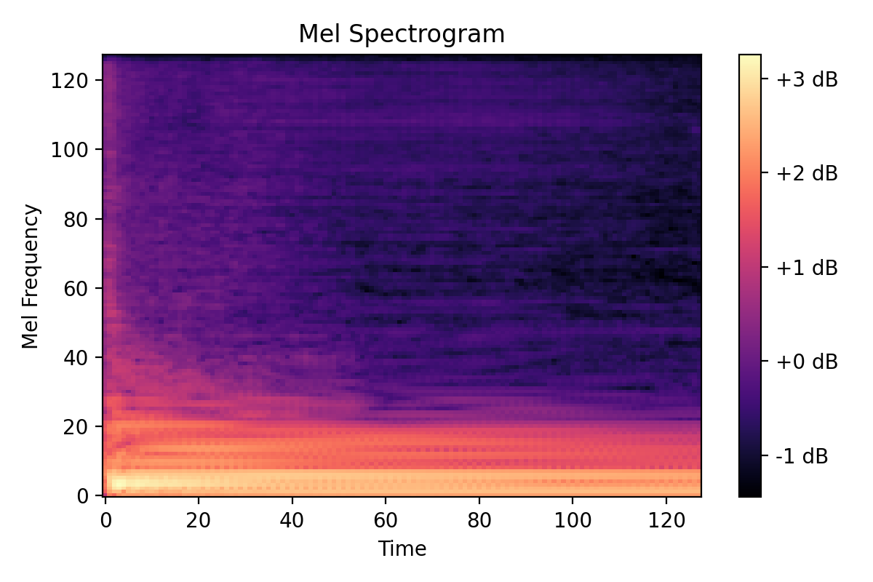

Instrument Classification Report
Predicted Instrument: Floor_Tom
Top Predictions:
Floor_Tom — Probability: 0.546
Bass_Guitar — Probability: 0.399
Vibraphone — Probability: 0.029
Electro_Guitar — Probability: 0.010

Organ — Probability: 0.005

13. Conclusion
The Week 7–8 deployment phase successfully converts the trained CNN model into a complete, user-friendly instrument recognition system. By integrating visualization, structured outputs, and report generation, the system achieves a full audio-to-report pipeline, making it suitable for academic evaluation and real-world applications.

